Cryptaborate

The future of project collaboration

Version 1.0.0

Opening Note …

In a day where creativity is being pushed from our schools due to funding issues, it is becoming more and more difficult to allow original artistic expression to not only be shared across society, but also created. There is a lot of talent out there that should not only be seen by the masses but also act as inspiration for the future artists that will pave the roads to all of that with which makes us all unique and human.

There is beauty in all of our differences and in a day and age where we are far too often told how we must act, look and behave, it is through artistic expression that the shackles are stripped and many singular voices have the means to touch others on so many different notes. Often for that impact to be seen however, it takes more than one person.

It is my hope that Cryptaborate can plant the seed and build the social platform necessary to allow emotion and creativity to be expressed as it should be and to provide a means for those single voices to multiply into many and spread across the world to allow their visions to be shared as far as their dreams envisioned.

I welcome you to join me on this social adventure ahead, where your projects can be dreamt and executed as you wished for them to be through the power of this social media ecosystem. More importantly, as the network grows in popularity you as the user have the power through Cryptaborate tokens to influence the direction of the network.

Let’s help free artistic expression and its place in our future and empower those single voices to be heard across the world.

Daniel Krotov

Table of Contents

Introduction 4

Cryptaborate Solution Overview 5

Cryptaborate Token 5

Acquiring token 6

Token Distribution 7

Example 8

Cryptaborate Wallet 9

Cryptaborate Ecosystem Architecture 10

App Design 11

Cryptaborate Project Creation 11

Cryptaborate Chatroom 12

Project Exploration 13

Cryptaborate Profile 14

Slated Roadmap 15

Team 16

Disclaimer 17

# Introduction

Cryptaborate is a decentralized social media platform on the Ethereum blockchain. Cryptaborate will provide a means for project collaboration anywhere from an artistic standpoint to a technical one. It will allow the visionary to initially setup a scoped set of placeholders for the project at hand, with which others can then apply to be a part of should they wish.

Cryptaborate will leverage blockchain technology to make sure that all transactions are safe, secure and accountable. The technology will provide a means with which users will be able to envision and complete projects not only for social gain and experience, but also in the future act as a platform to monetize from and for larger corporations to organize rewarding contests. This may include social contests to create anything from commercials created by and for their target market to …

With Cryptaborate tokens, users will be able to spend them across the Cryptaborate application ecosystem. These will include the ability increase clout and presence on the network, as well as up-vote favorite projects to give them more visibility across the network.

Cryptaborate was thought up as a final project and will be executed by a larger team should the coin be funded.

Join us in the discussion via … and follow us on twitter at …

# Cryptaborate Solution Overview

## Cryptaborate Token

The Cryptaborate token is an ERC-20 token.

Cryptaborate will provide an exciting new platform that will allow for the right resources to have a way to collaborate on projects simply and easily and for the creator’s visions to be experienced as they were meant to.

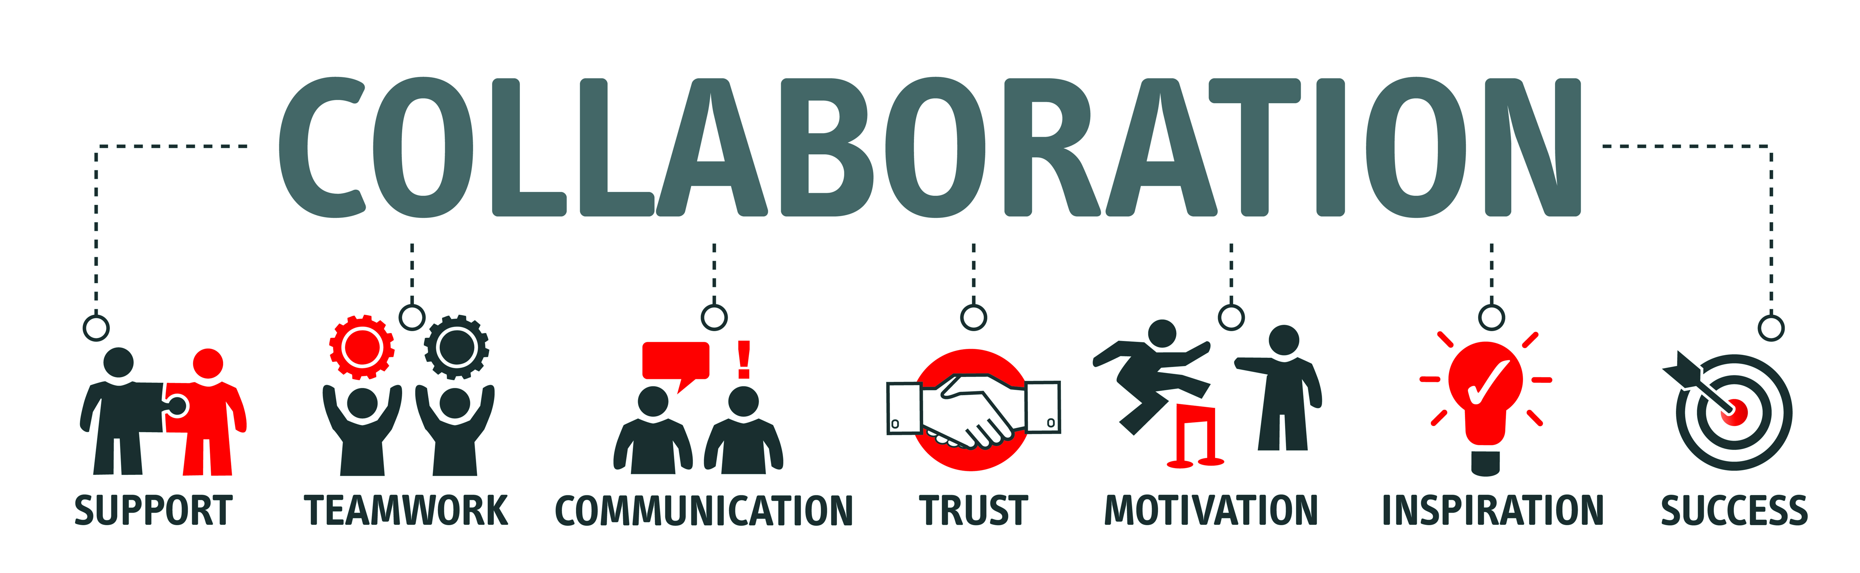

Many projects today end at an idea because many don’t know the next steps necessary or how to achieve such large efforts alone. The Cryptaborate ecosystem hopes to fill that gap and allow for the finding of those pieces much easier all the while providing incentive to the overall users of the network. With the growth of the network, the number of resources available for various projects will increase and the pool of talent and quality will expand. I believe that that as more partners and project creators get involved, the ability for sustainable growth will increase over time through successfully executed projects that come to fruition.

The Cryptaborate ecosystem will also allow its users to accumulate Cryptaborate through their various projects as well as through purchase via Ethereum. The Cryptaborate token can then be used by the user to gain more visibility on projects of interest It is my hope that Cryptaborate will provide a means to free creativity and allow for all dreams to be seen, not only those that have larger VC funding groups.

## Acquiring token

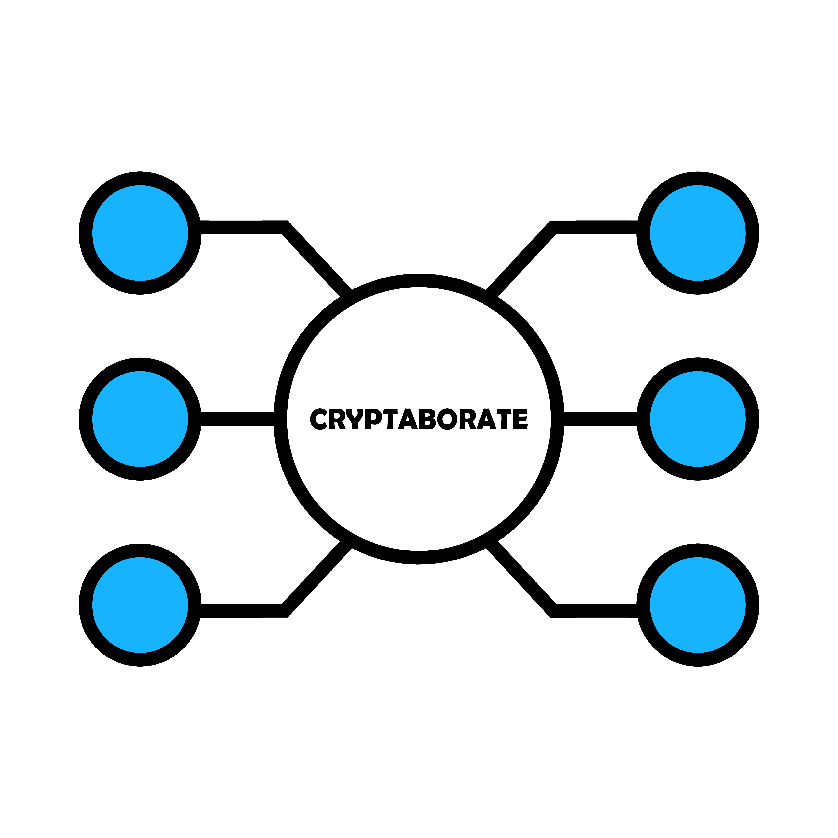The Cryptaborate token will be able to be purchased via Ethereum or through the value produced across the network. As each user produced value on the network, they earn Cryptaborate tokens for their work on the project as a whole. This is agreed upon during project setup based on importance placeholders. Upon successful completion of the project, the Cryptaborate tokens are released to all participating accounts for use on the network as the user sees fit. The tokens are representative of the users contribution to the network and can be used to influence the direction the network takes as a whole. The more Cryptaborate earned, the more value the user brings and therefore the more power the user has upon the network.

30% of the total Cryptaborate pool will be available for users project transactions. For the upcoming years head, a total of 300 Million Cryptaborate will be distributed to users via the means described above. This amount will be halved annually over the course of a predetermined number of years. At the end of this period, all tokens will have been mined and distributed.

This described model will award early adopters as rewards will be reduced over time at an exponential rate.

All transactions will be verified and secured via Ethereum smart contracts and allow for safe transactions across the user-base. All transactions will be tracked upon the Ethereum ledger, which will provide a trail for all users and partners to track.

## Token Distribution

Cryptaborate token distribution will both occur automatically via contracts which will run on the Ethereum blockchain as well as transactions between users. Upon successful completion of the project, Cryptaborate tokens will be allocated across all parties for their work and effort provided for the project. This will be controlled via the main project creator’s management portal.

------- HAVE TO STILL WORK ON A POSSIBLE ALGORITHM FOR THIS ---------

Examples below

----------------------

Token Exchange – 30%

Runtime Network Transactions – 30%

Dev Team – 5%

Community Dev – 20

Early Backers and Advisors – 5%

Future reserves – 10%

As the Cryptaborate users add valuable content to the ecosystem, they will receive rewards based on their contribution to the network. Each year these rewards will decrease over time.

## Example

## Cryptaborate Wallet

This will allow for easy access and management of each users Cryptaborate tokens. Each user will be able to see where their current standing is on the network as a whole by means of their current ownership in the network and also track their current income and contributions made. The wallet will also act as the portal with which the user can gift other users Cryptaborate tokens to get them started faster.

This will also open up the possibility for users to persuade others a bit more should it be necessary to get them on their project or to provide deeper funding to a project which one holds dear to their hearts.

## Cryptaborate Ecosystem Architecture

The ultimate goal of the Cryptaborate ecosystem is to allow artists and other project owners to complete their projects simply and efficiently by providing a social network that allows for the easy collaboration on these projects.

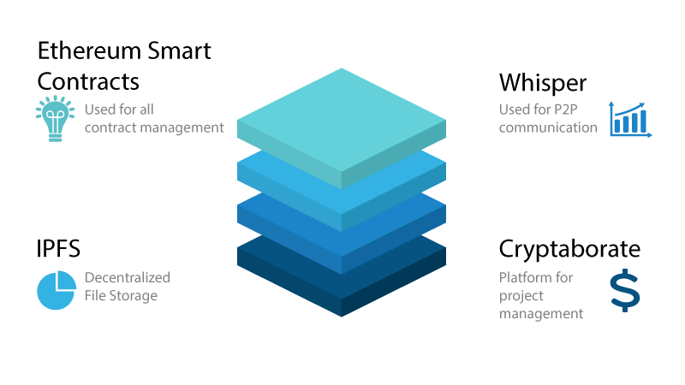

## App Design

### Cryptaborate Project Creation

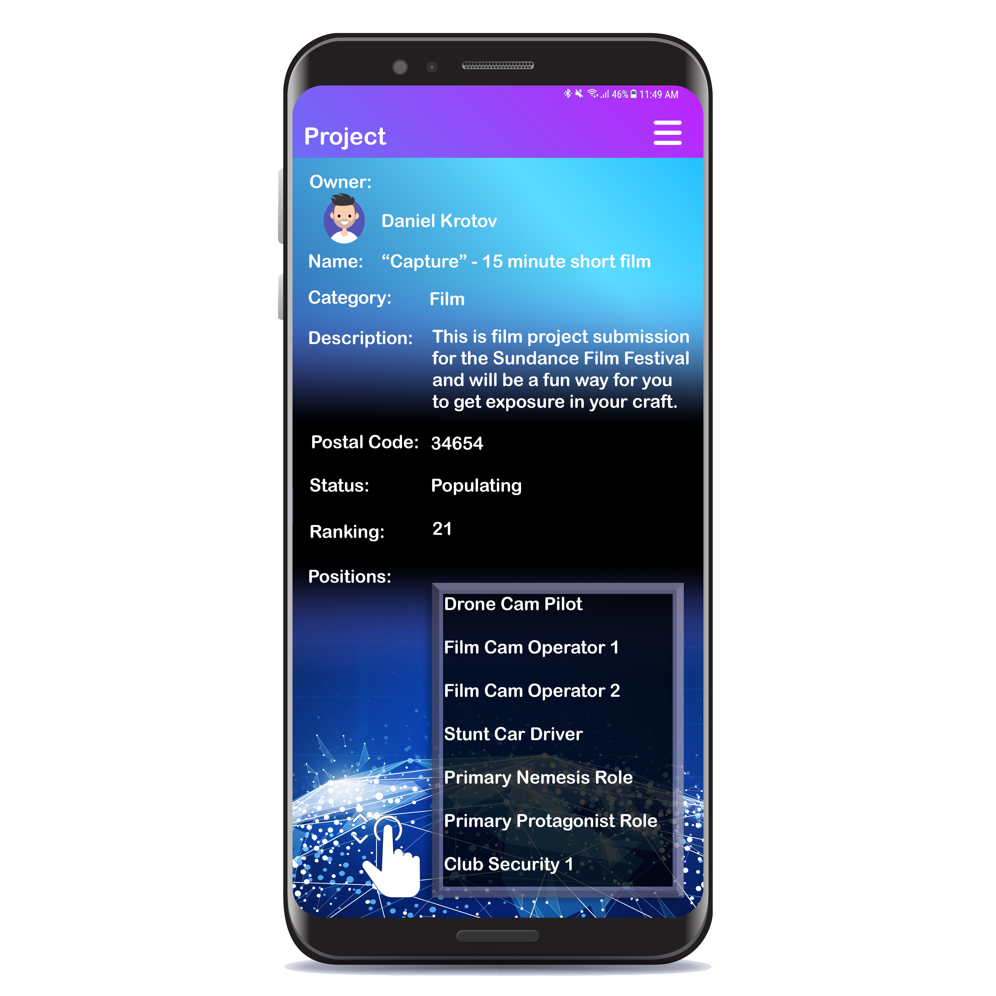

The Cryptaborate project portal will provide the user an easy to use interface for the creation of their project and all the associated details and user positions requested. Once users apply for the various positions, the project owner will be able to manage who is assigned the positions as well as share potential openings for the project in group chat channels.

### Cryptaborate Chatroom

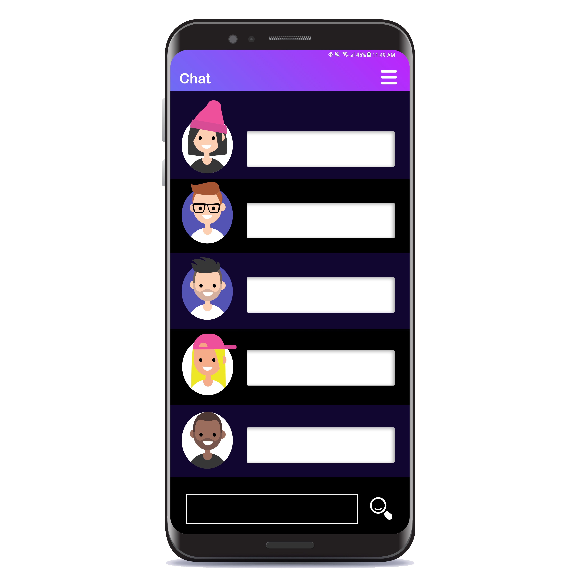

The chatroom will allow users to communicate to friends as well as ask questions regarding projects with which they may be interested in.

### Project Exploration

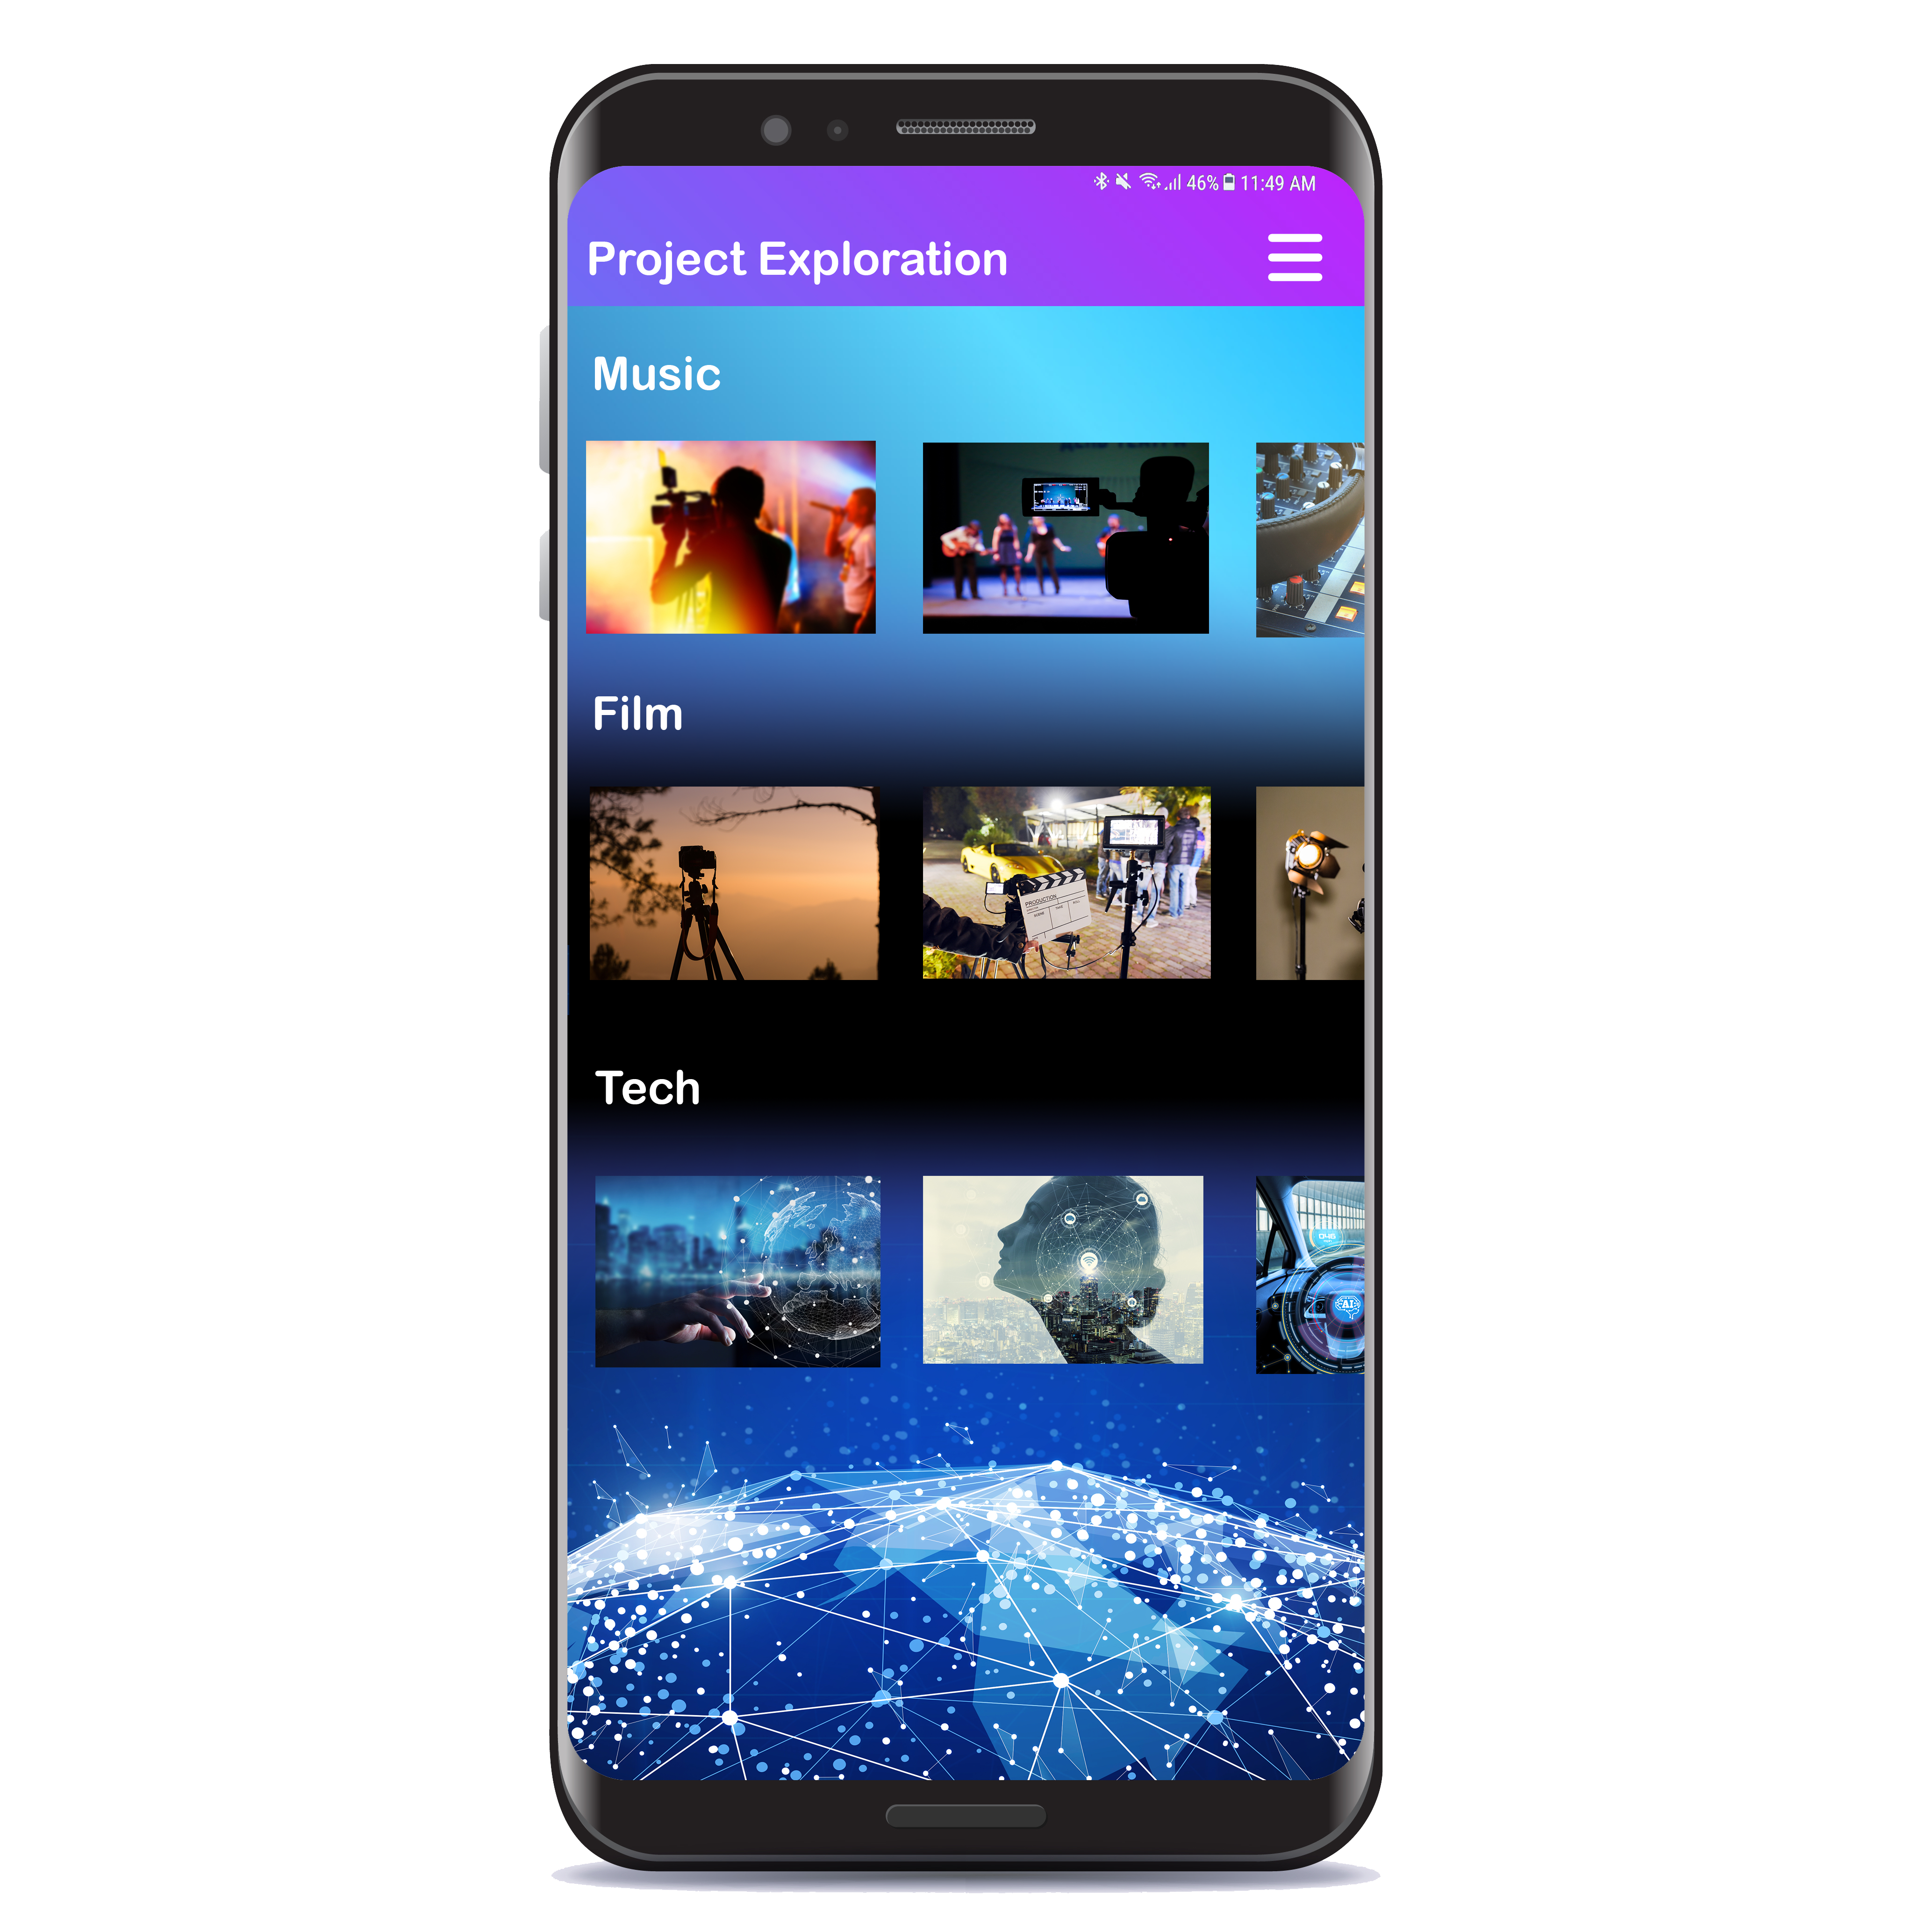

The project exploration page will act as the portal for potential projects of interest and project discovery. When a user wishes to find their next project to apply to or support, they will go about searching in areas of interest.

### Cryptaborate Profile

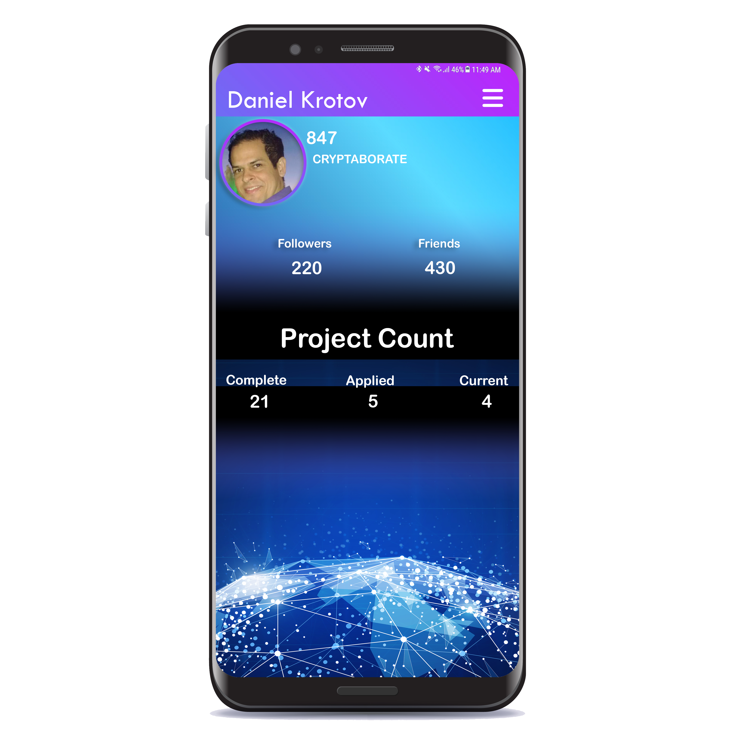

The profile page will be the central location that the user will be able to manage their profile as well as check the current status of their wallet, projects, followers and friends.

Any security related info with regards to what others can see and cannot see will also be able to be controlled from this location.

## Slated Roadmap

2018 Q3 – Founded, early advisors joined, development

2018 Q4 – Private exchange (Alpha / Beta)

2019 Q1 – 1st release, wallet dev

2019 Q2 – wallet alpha/beta, next dev steps

2019 Q3 – Wallet release / next dev steps alpha / beta, vault development

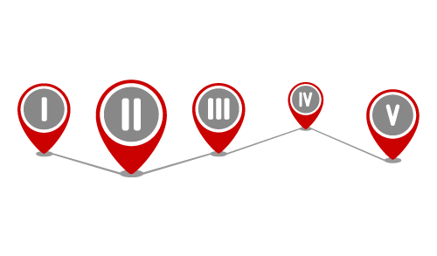2019 Q4 – Next dev steps release, alpha /beta vault

2020 Q5 – Vault release

## Team

Daniel Krotov / Founder



Daniel Krotov is a software engineer based out of Florida Tampa Bay area. With a background in Deep Learning, game development and web technologies it was only a matter of time before he was drawn into the intrigue of blockchain technologies and how these pieces could all fit together.

## Disclaimer

This whitepaper has been prepared solely for the purpose of informing potential contributors to the Cryptaborate ecosystem with a proposal for the direction the network will take from a technical side of things. This whitepaper is non-binding in all respects and does not create any legal obligation of any kind on any person or entity. The following is intended to outline the general product direction and is intended for informational purposes only. IT is not a commitment to deliver any material, code or functionality and should not be relied upon in making purchasing decisions.

The end product of the Cryptaborate ecosystem is dependent on several factors including regulatory risks, contributor participation and the adaptation of the technology and network as a whole. Nothing in this whitepaper or otherwise shall require any steps to develop or otherwise implement the Cryptaborate ecosystem.

I reserve the right to abandon the Cryptaborate ecosystem and/or change the implementation of the ecosystem contemplated by this whitepaper at any time and for any reason. Cryptaborate users and other contributors are advised to contribute and participate at their own risk and without reliance on any statement contained in this whitepaper.